INTRODUCTION

Customer relationship management (CRM) is an approach to manage a company’s interaction with current and potential customers. It uses data analysis about customers’ history with a company to improve business relationships with customers, specifically focusing on customer retention and ultimately driving sales growth.



**CRM MARKETING**

PROBLEM DEFINITION & DESIGN THINKING

1. Empathy map

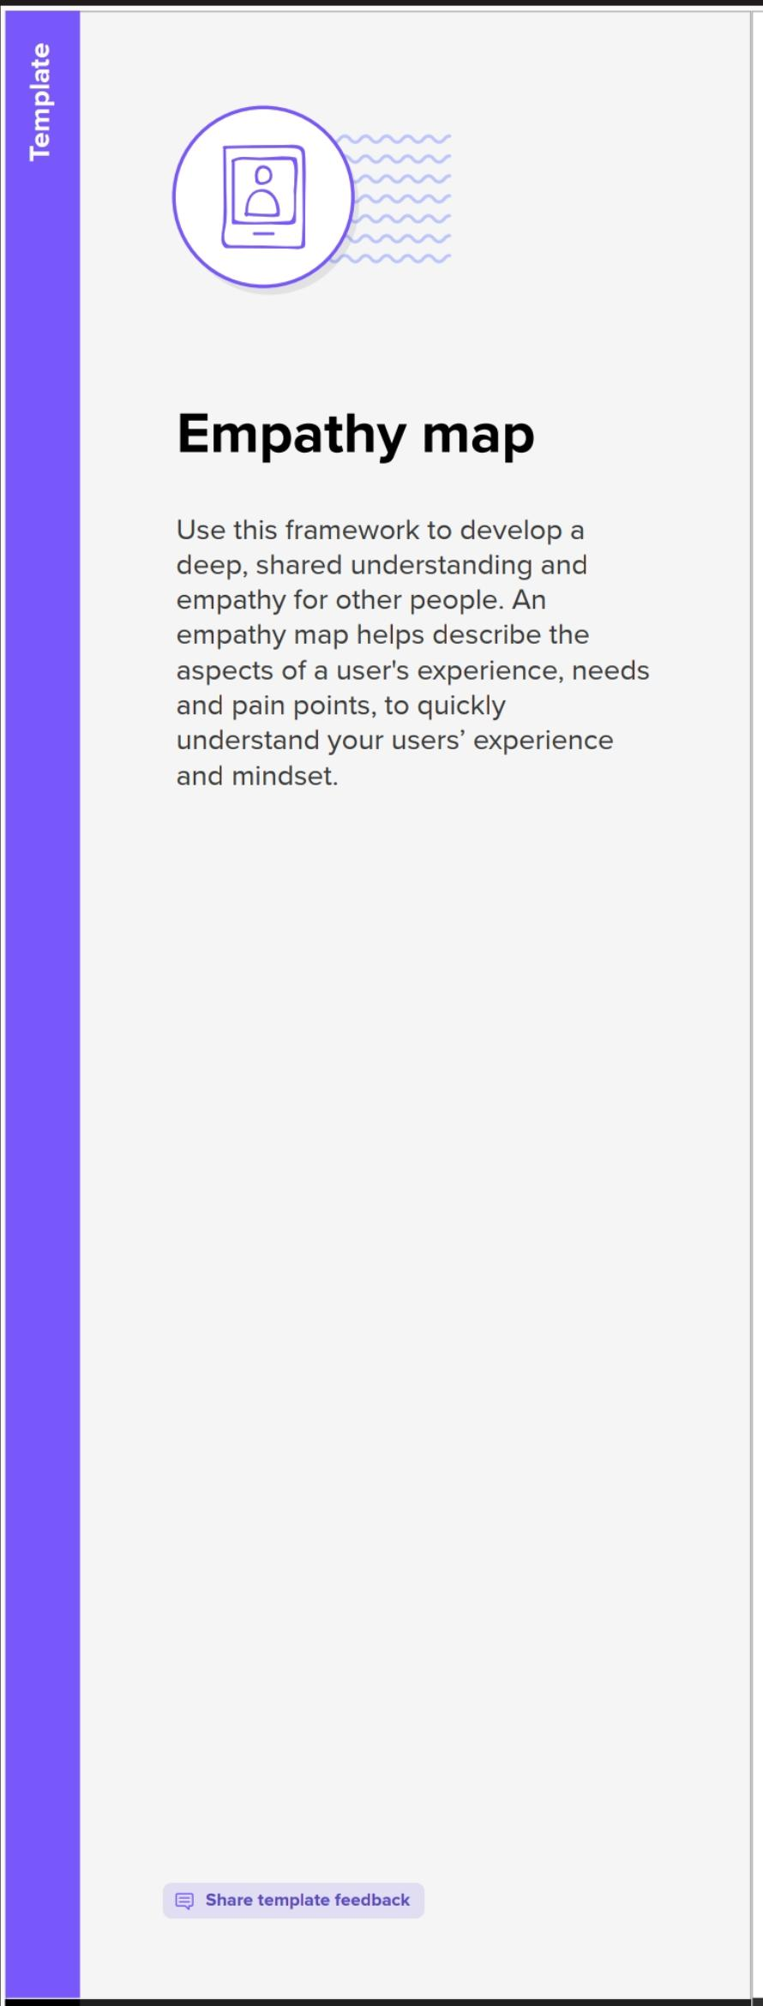

2) **Ideation &brainstorming** 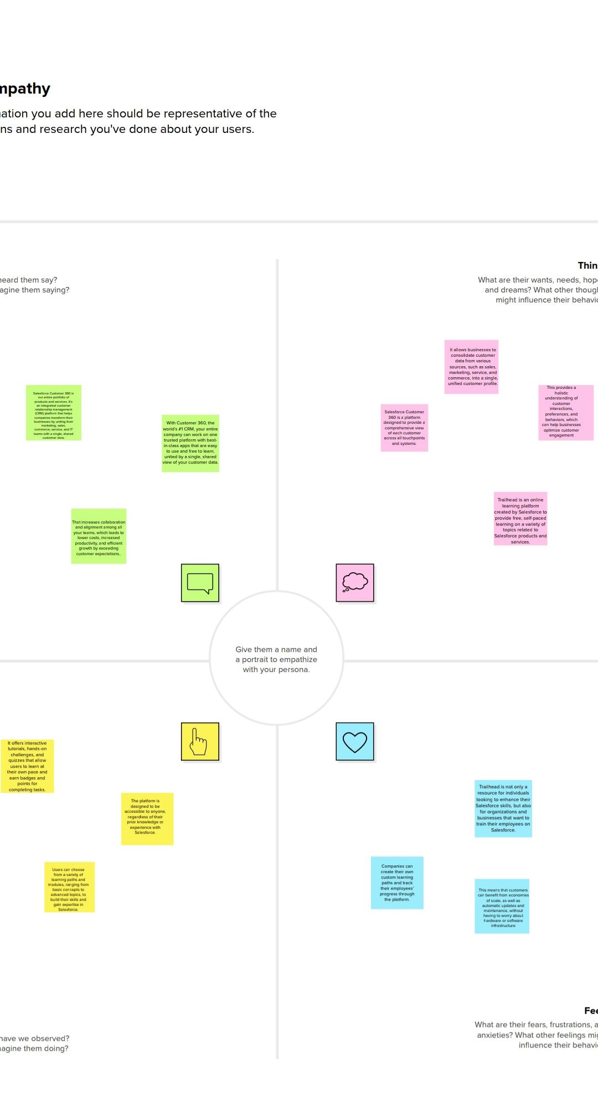

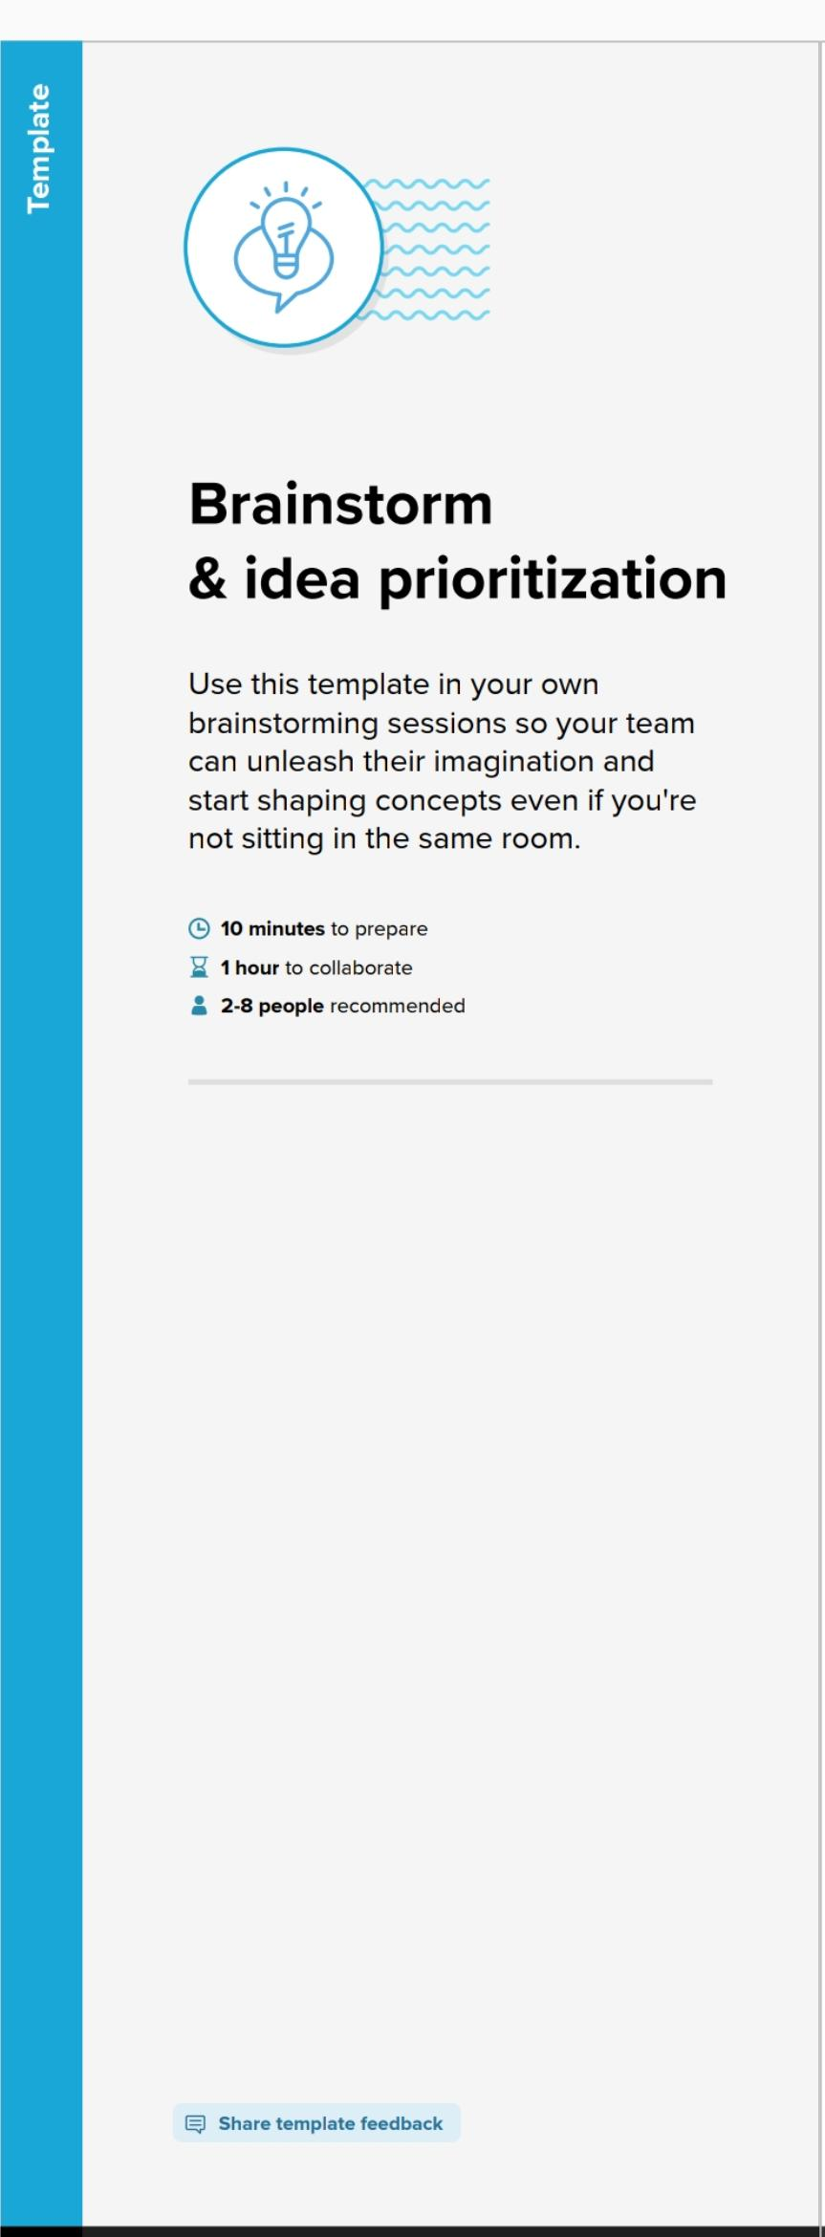



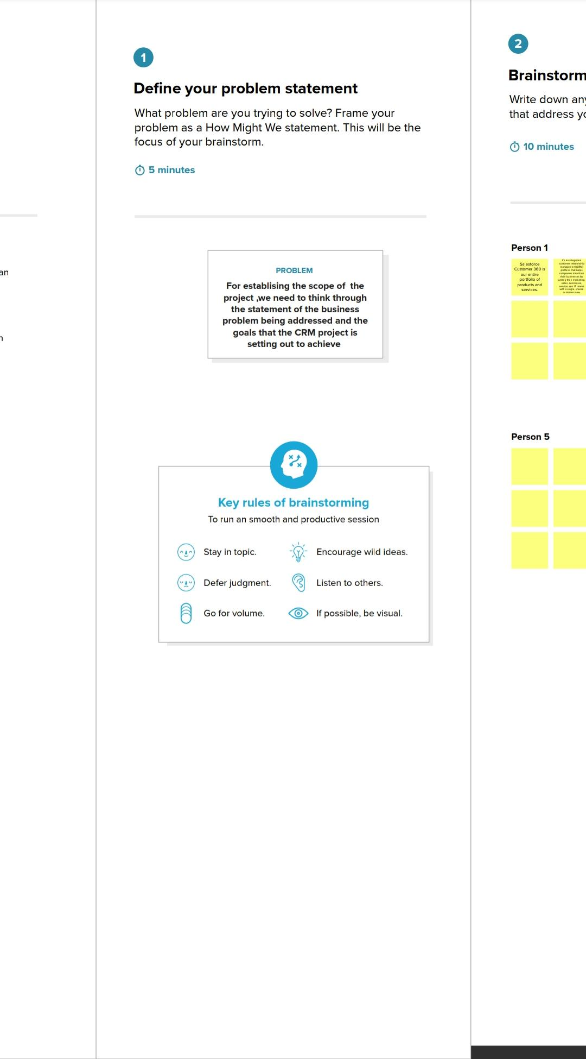

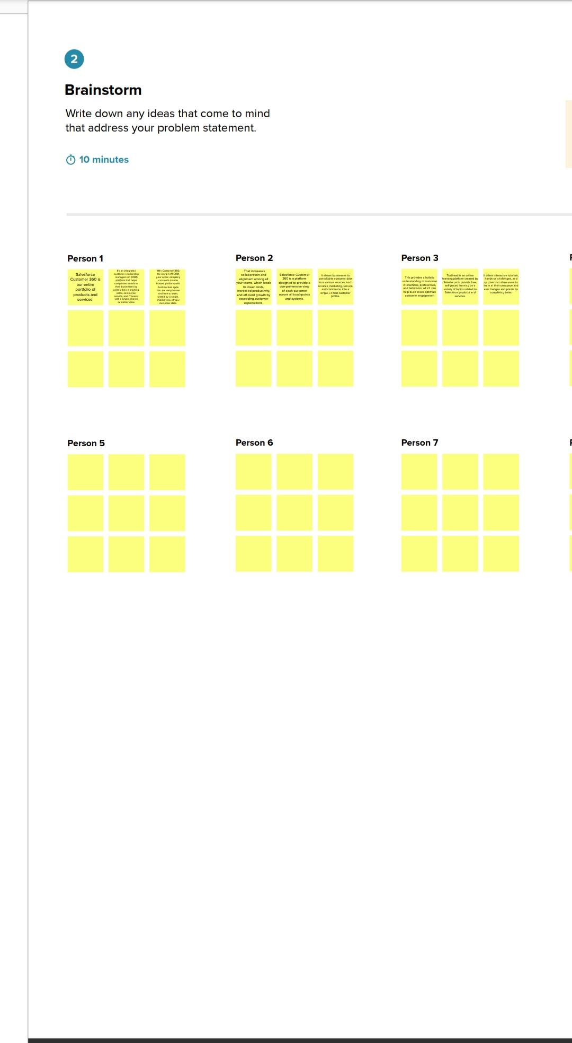





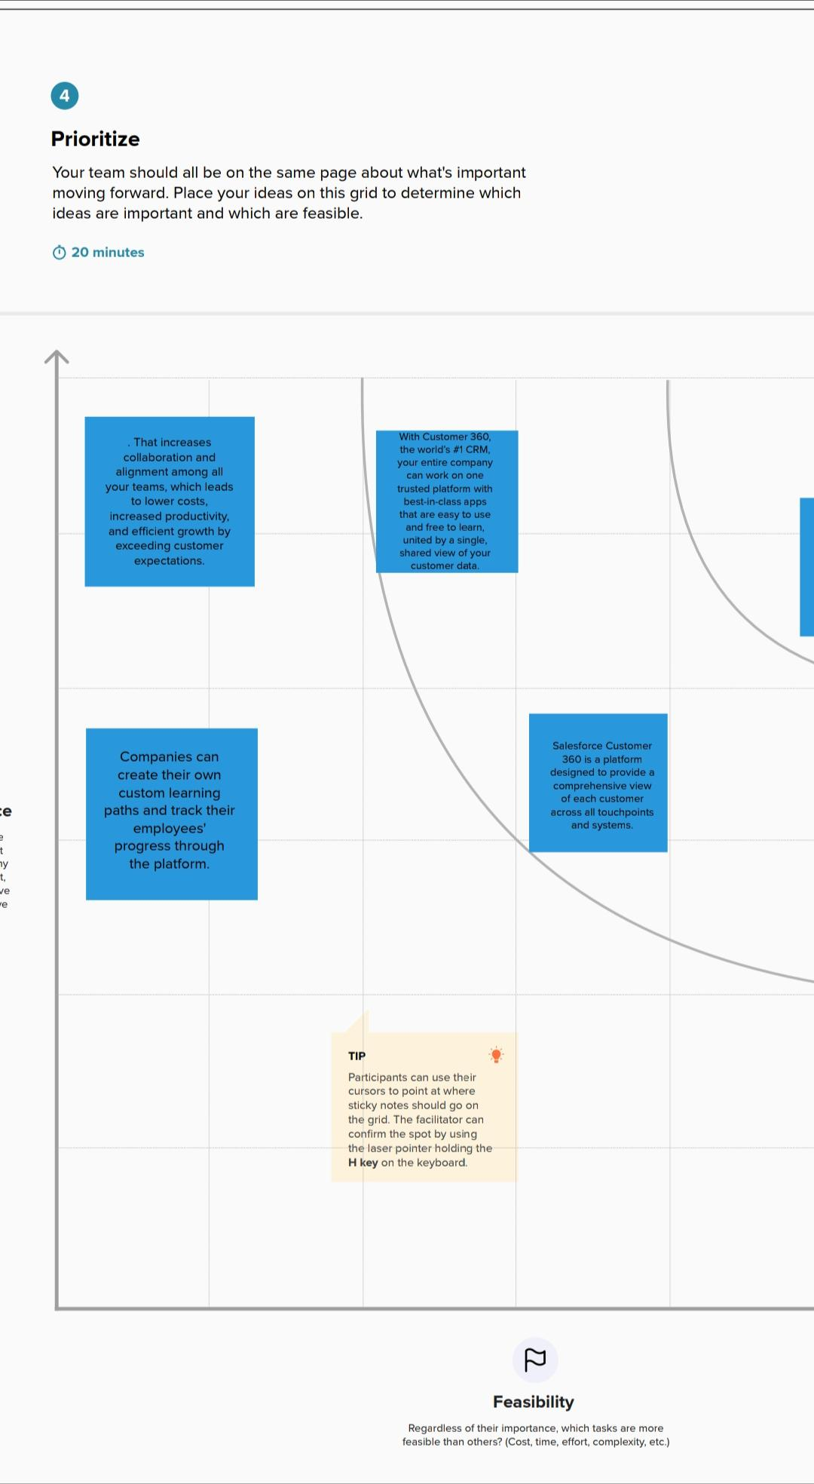

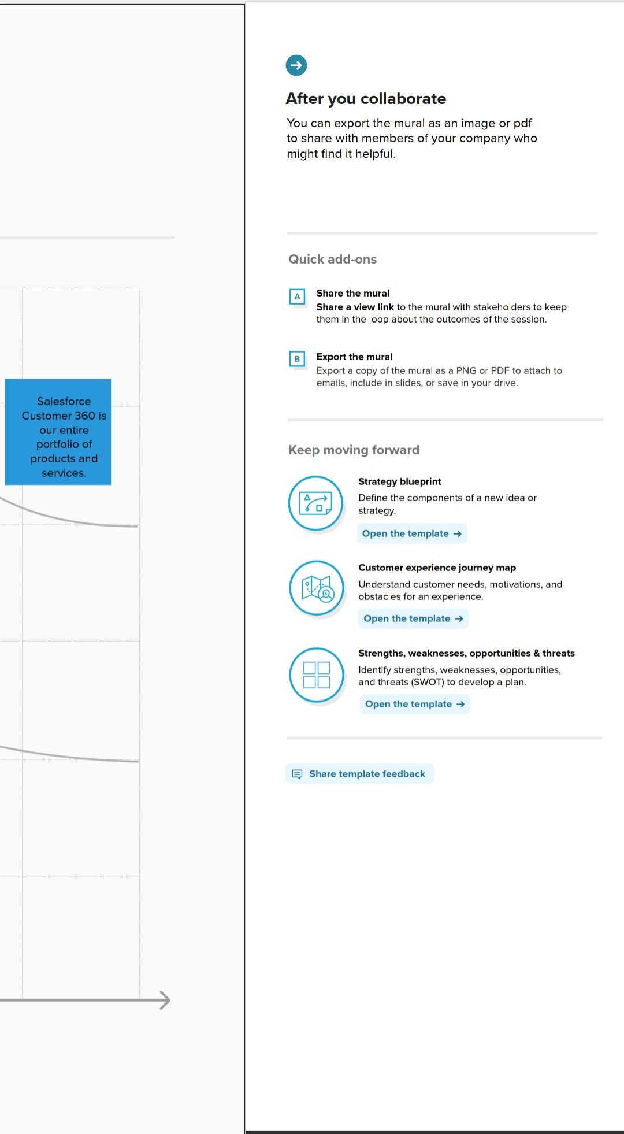

**APPLICATIONS**



**LEAD NURTURING:**

**Source of Leads – Personalized, targeted emails, Direct Mail, Sales Call, Social Media, Content Marketing, Social Media and PPC Advertising. Don’t forget a Lead, Follow up Quickly and Convert it Quickly**



**LEAD MANAGEMENT:**

**Optimize your sales strategy in effective and efficient way. Capturing leads, tracking their activities and behaviour.**



**APPLICATION MANAGEMENT:**

**Digitise your entire application process. It’s good practice for schools/colleges/universities to make the application process as smooth and simple as possible for prospective students.**



**ENROLMENT:**

**Wow, your final Goal is ended Here.**

**Get more admissions**

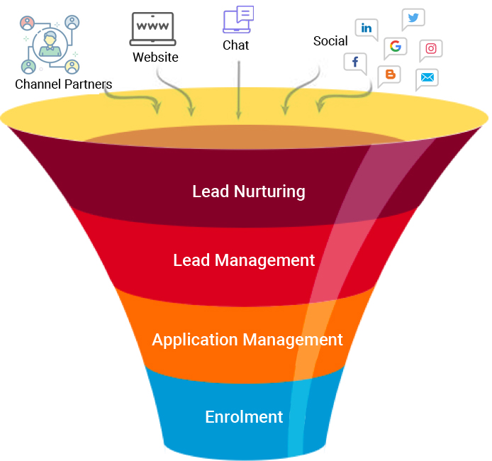

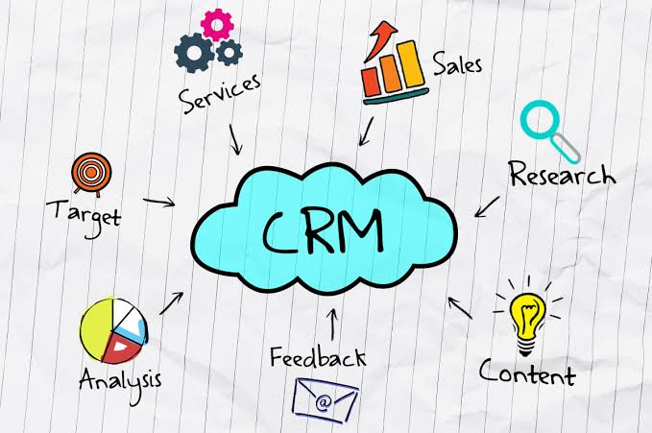

**TRAILHEAD PROFILE PUBLIC URL**

**Team leader :**

**https://trailblazer.me/id/srikanth1804**

**Team member 1:**

**https://trailblazer.me/id/abishek0908**

**Team member 2 :**

**https://trailblazer.me/id/mathankumar007**

**Team member 3 :**

**https://trailblazer.me/id/pkingsp3**

**ADVANTAGES AND DISADVANTAGES**

**Pros :**

**It allows for the consolidation of customer data and the basis for deep insights.**

**It speeds up the sales conversion process.**

**It increases staff productivity, lowering time-cost.**

**It allows geographically dispersed teams to collaborate effectively.**

**Improves customer experience by allowing personalisation and improved query resolution.**

**Cons :**

**Customer experience may worsen due to staff over-reliance on the system.**

**Security and data protection issues with centralised data.**

**The excess initial time and productivity cost at the implementation.**

**Requires a process-driven sales organisation.**

**CRM may not suit all businesses.**

**CONCLUSION**

**Customer Relationship management is a business strategy that enables a business organization tomaximize revenue, customer satisfaction, profitability through strategic mobilization, organization, and management of customer’s interests and desires. BWM has traversed numerousbusiness challenges that made it establish a CRM that will foster customer relationship as a baseline for market strengthening and diversification. BMW has diversified its market in various global markets through the initiation of the CRM systems. The system has significantly contributed to the company’s financial, operational, managerial and development initiatives with a robust customer relationship that has fostered great sale of its product**